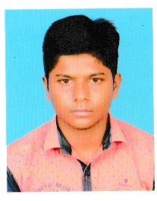

#### Summary

* I have been studying basic knowledge in Data Science.
* I’m so eager to work with your

organization.

* Hope I get the opportunity to work with you.

Sudarson N

Contact:

Ph.no:9585716375.

Gmail: sudarsonn@yahoo.com.

Address: 7c samuvel colony,

Pullambadi-621711.

Technical Skills

Reference:

 @ Sudarson N

https://www.linkedin.com/in/sudarson-n

2017

Completed my 10th in DALMIA HIGHER SECONDARY SCHOOL with 90.8%.

2019

Completed my 12th in BHRATHI HIGHER SECONDARY SCHOOL with 72.4%.

Now

Pursuing my Graduation in K.Ramakrishnan College of Engineering.

EDUCAT

I

ON



python

Languages:

Tamil.

English.

* Name Sudarson
* Father’s Name Nambiappan
* Mother’s Name Kalyani
* DOB 03/10/2001
* Gender Male
* Nationality Indian
* Playing games
* Team Work
* Logical Thinking
* Environment adaptability

Hobbies

* IOT based fish feeder

Projects

Skills

Personal Info